Assignment No 3 Linear Algebra and Analytical Geometry 19SW I / II

Q1. Solve the following systems of linear equations:



**Solution:**

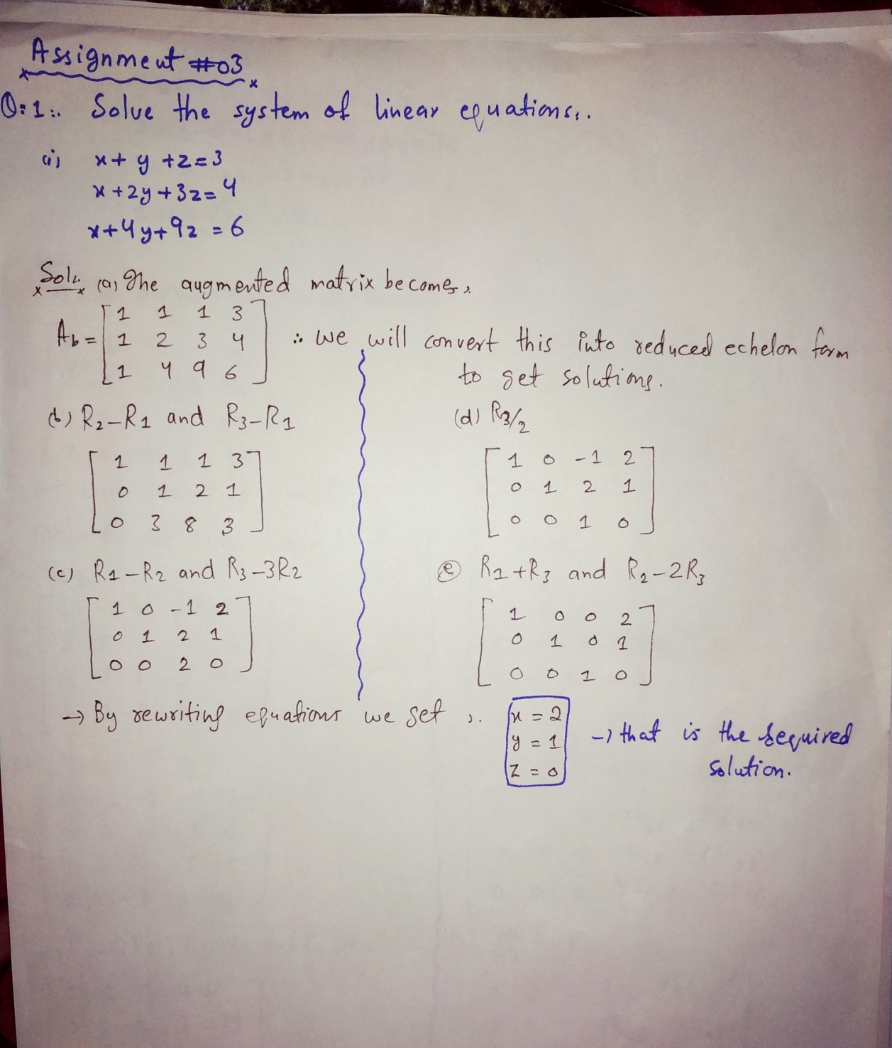

$$\left(ii\right)\begin{matrix}2x_{1} & + & x_{2} & + & 2x_{3} & + & x_{4} & = & 6 \\ 3x_{1} & - & 6x_{2} & + & 6x_{3} & + & 12x_{4} & = & 36 \\ 4x_{1} & + & 3x_{2} & + & 3x_{3} & - & 3x_{4} & = & -1 \\ 2x_{1} & + & 2x_{2} & - & x_{3} & + & x_{4} & = & 10\end{matrix}$$

**Solution:**

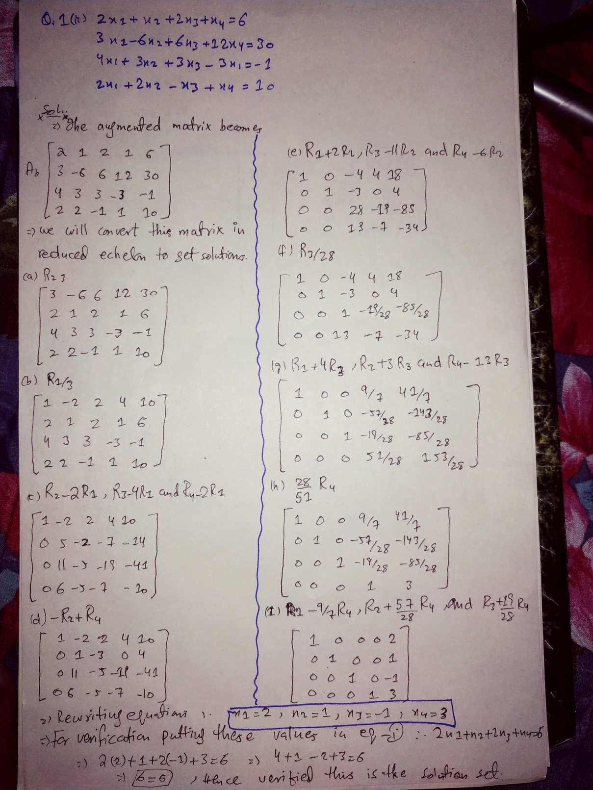

Q2. Test the consistency of the following equations and solve them if possible:



**Solution:**

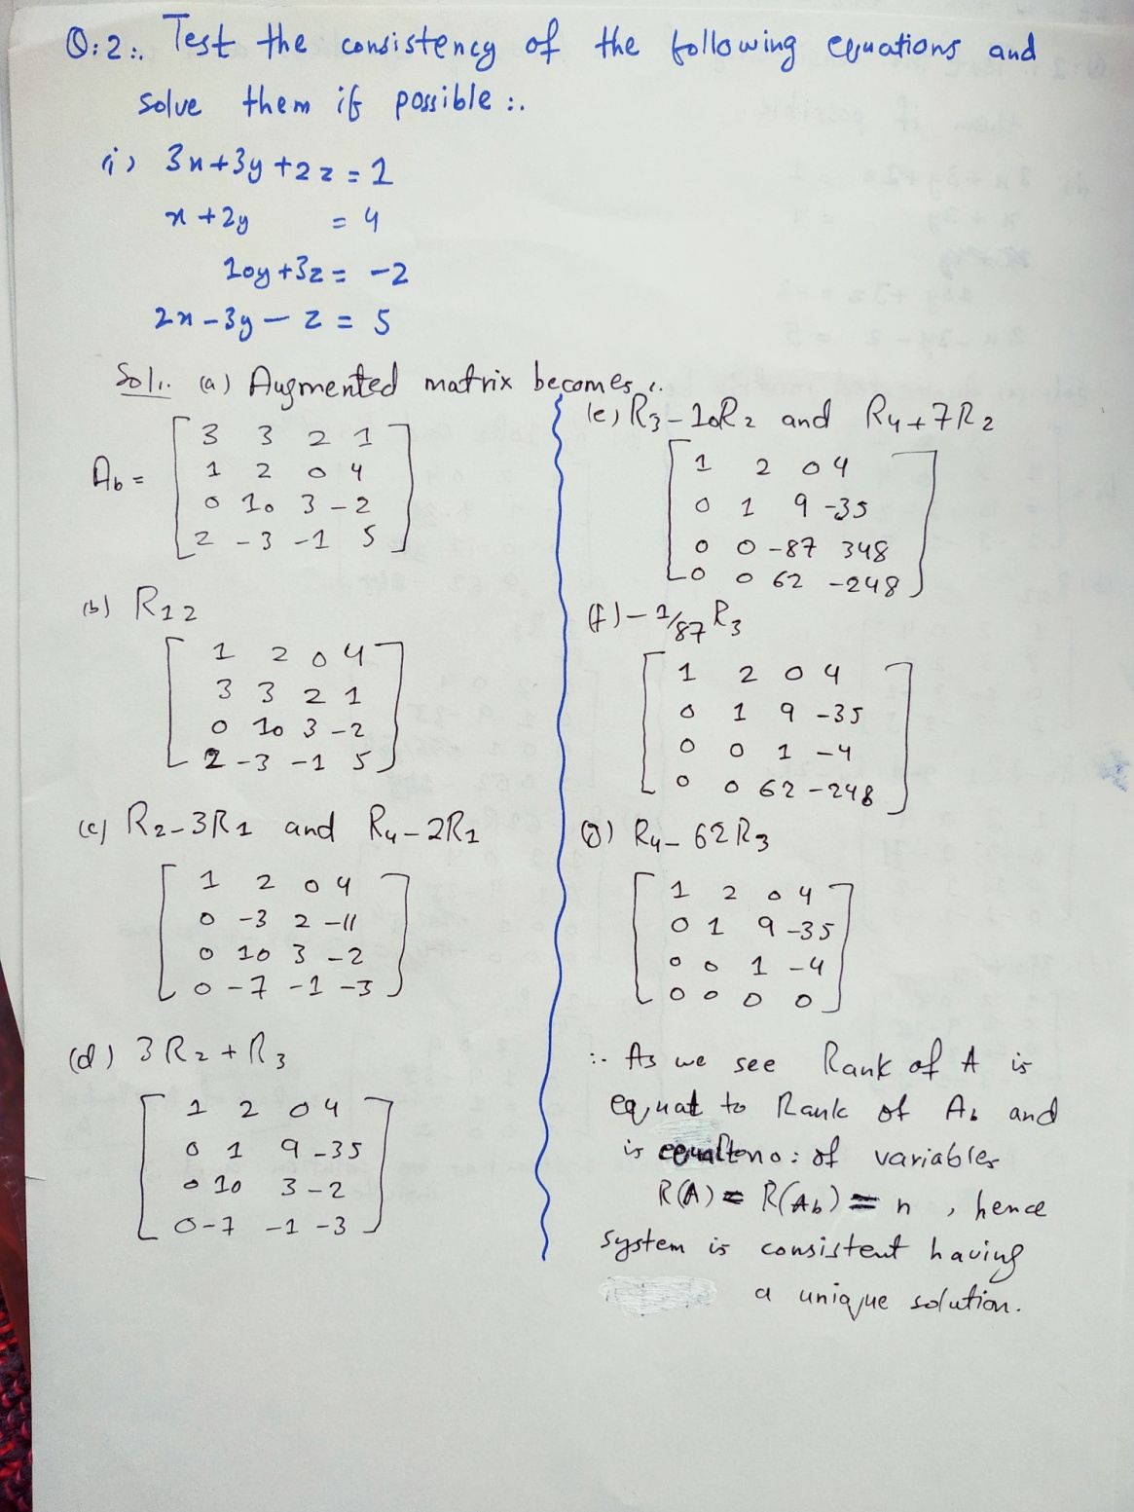



**Solution:**

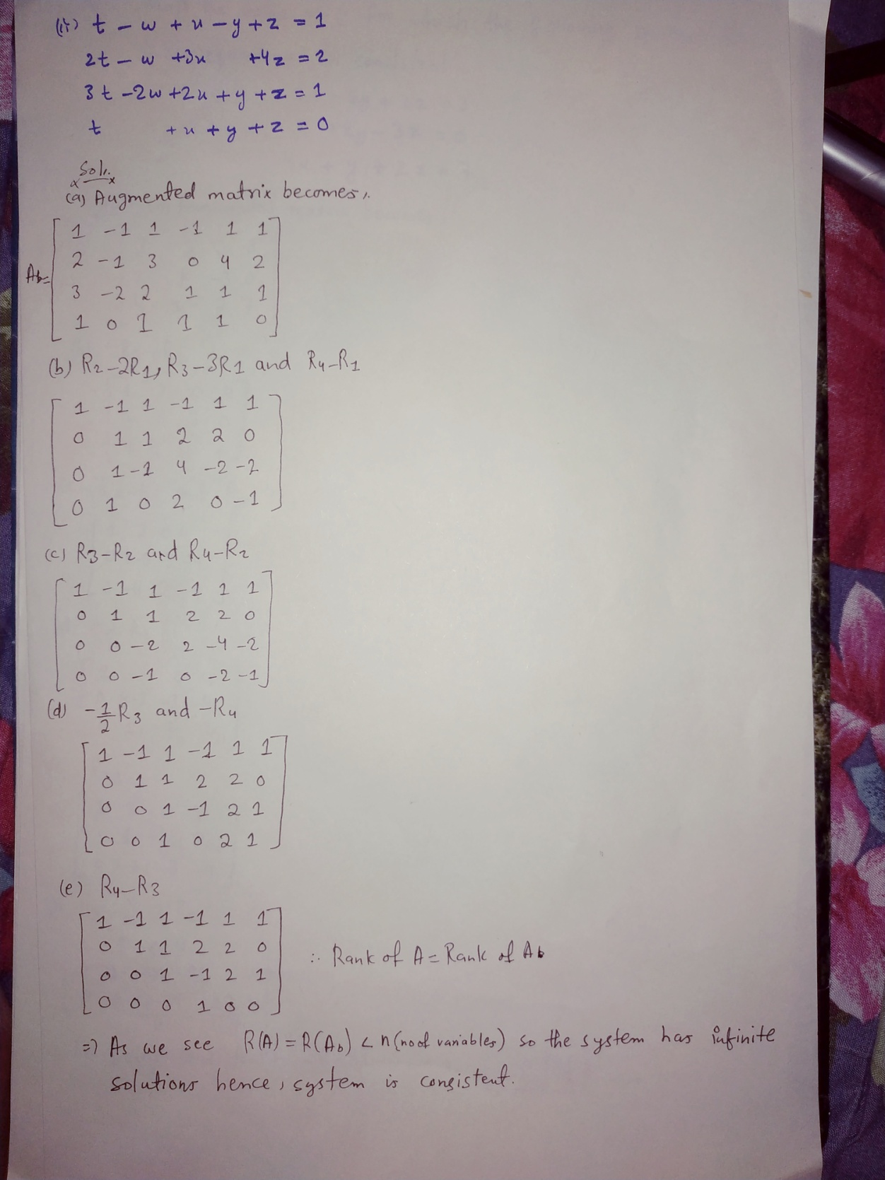

Q3. Find the value of *k* for which the following system of equations is consistent:



**Solution:**

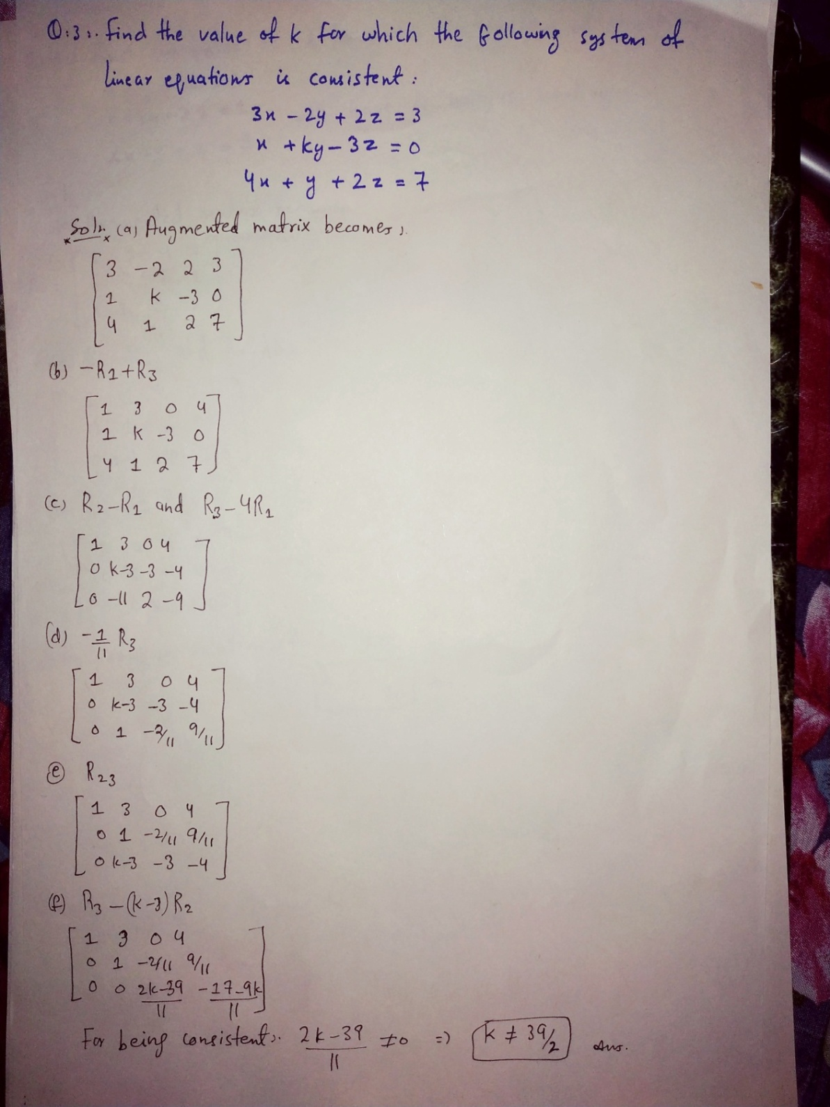

Q4. Find the value of for which the system of equations



will have a unique solution.

**Solution:**

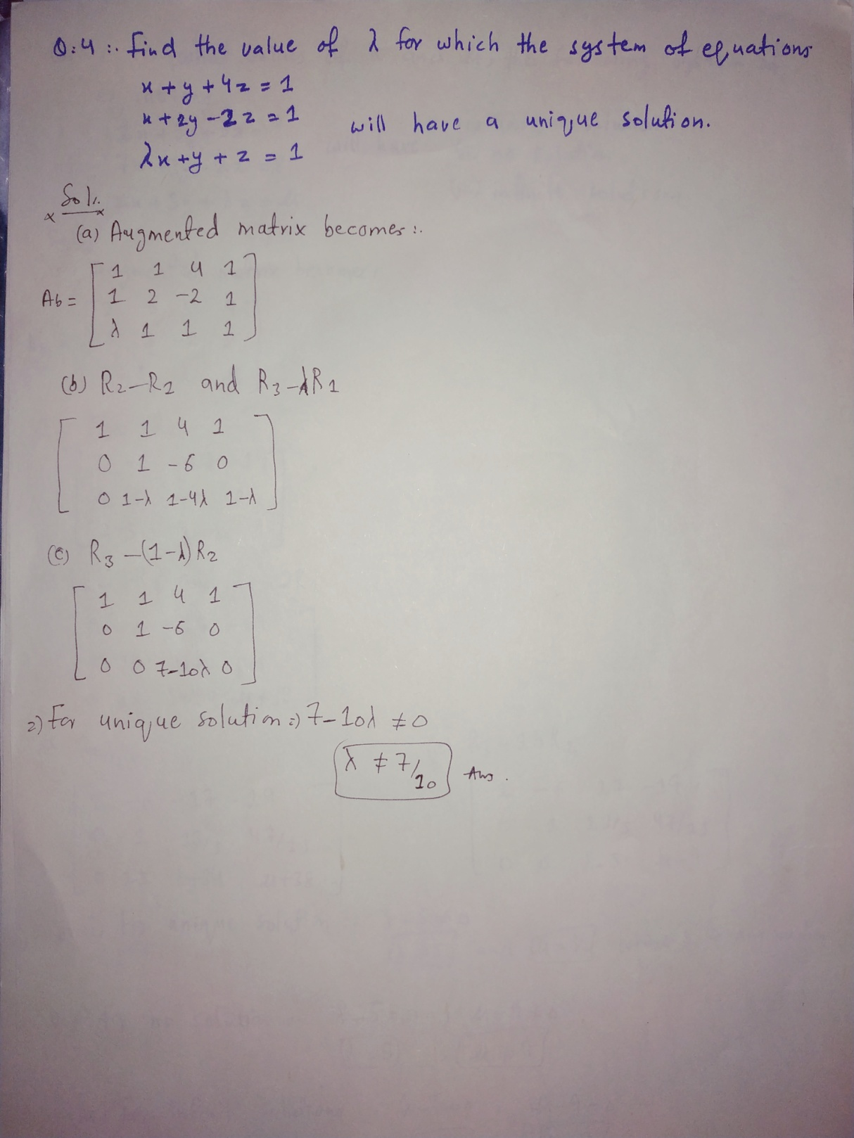

Q5. For what values of  and , the following system of equations



will have (i) unique solution (ii) no solution (iii) infinite solutions

**Solution:**

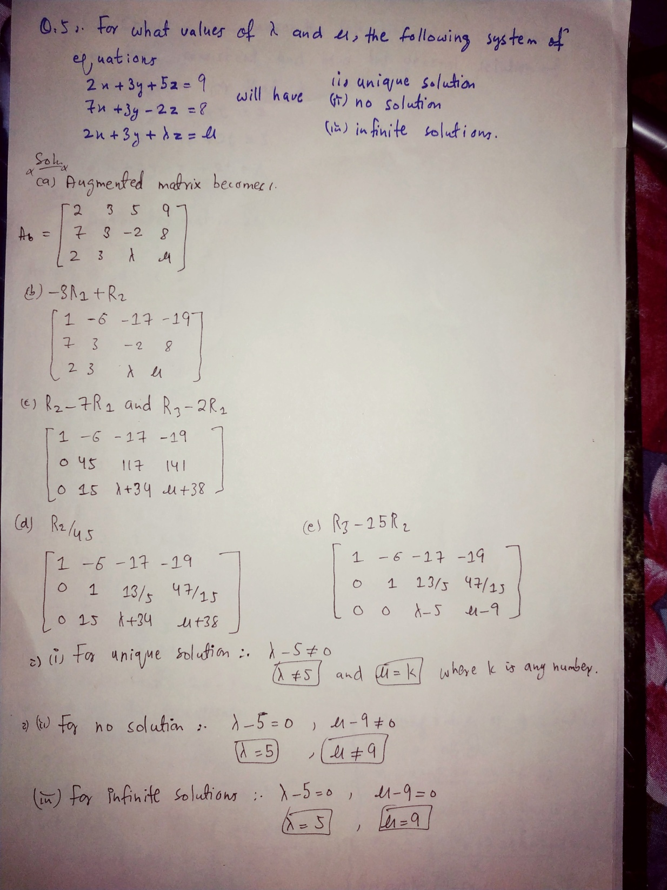

Q6. Choose  that makes the following system of linear equations consistent and find the general solution of the system for that .



**Solution:**

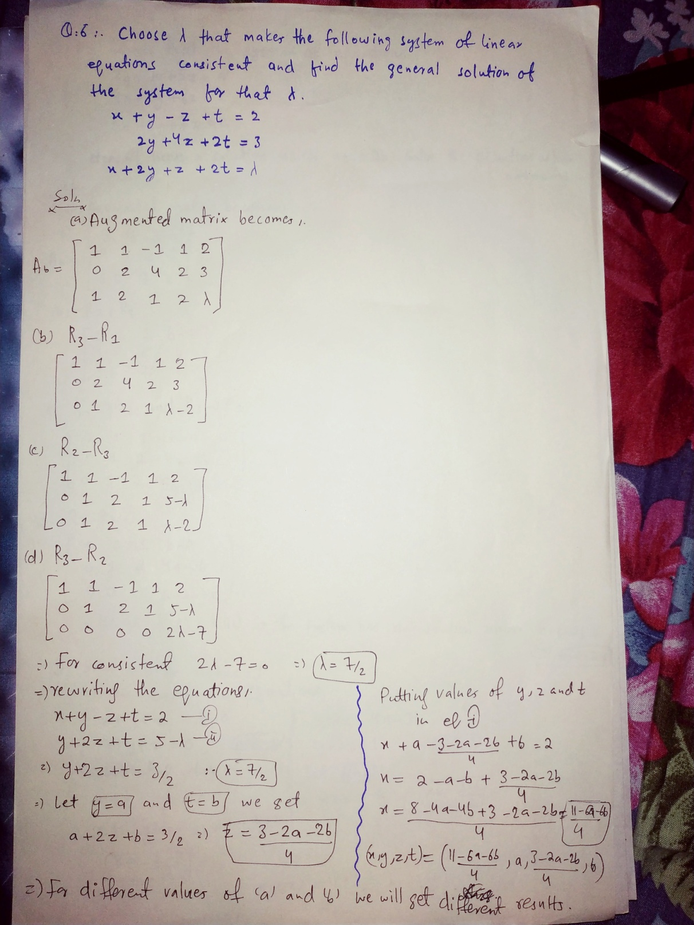

Q7.Show that the system of equations



doesn’t have a solution unless Solve the equations when 

**Solution:**

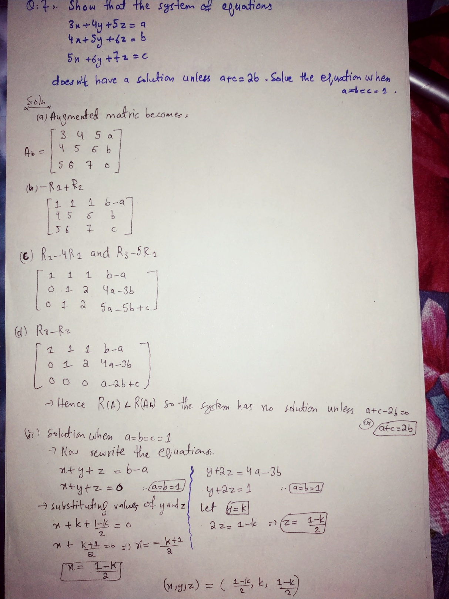

Q8. Find the value of *k* such that the system of equations



has non – trivial solutions. Find the solutions.

**Solution:**

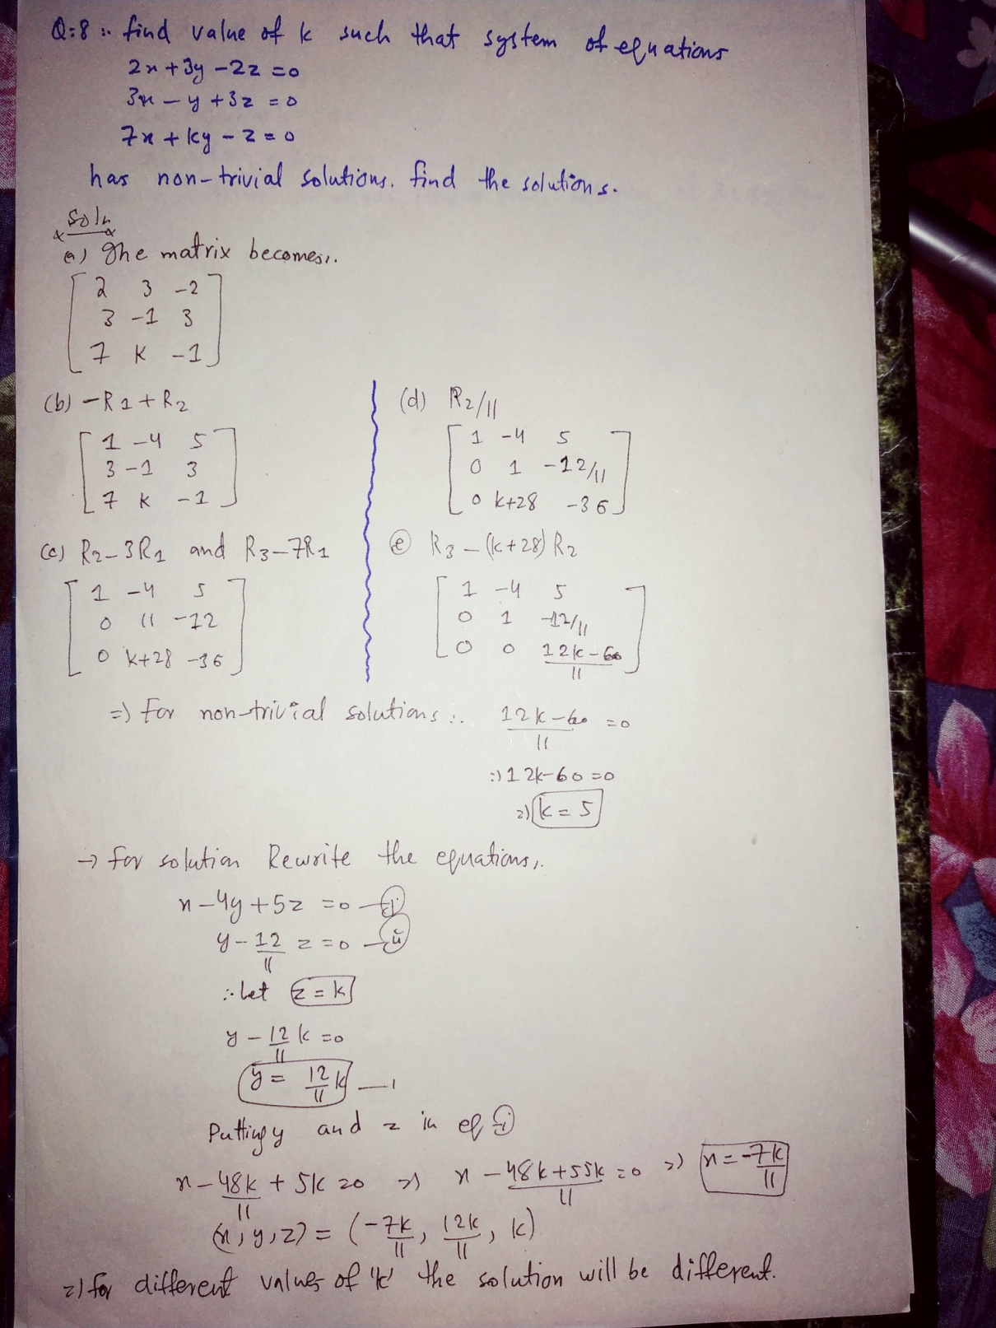

Q9. Find the values of *k*, such that the system of equations



has non – trivial solutions. Hence, find the solution of the system.

**Solution:**

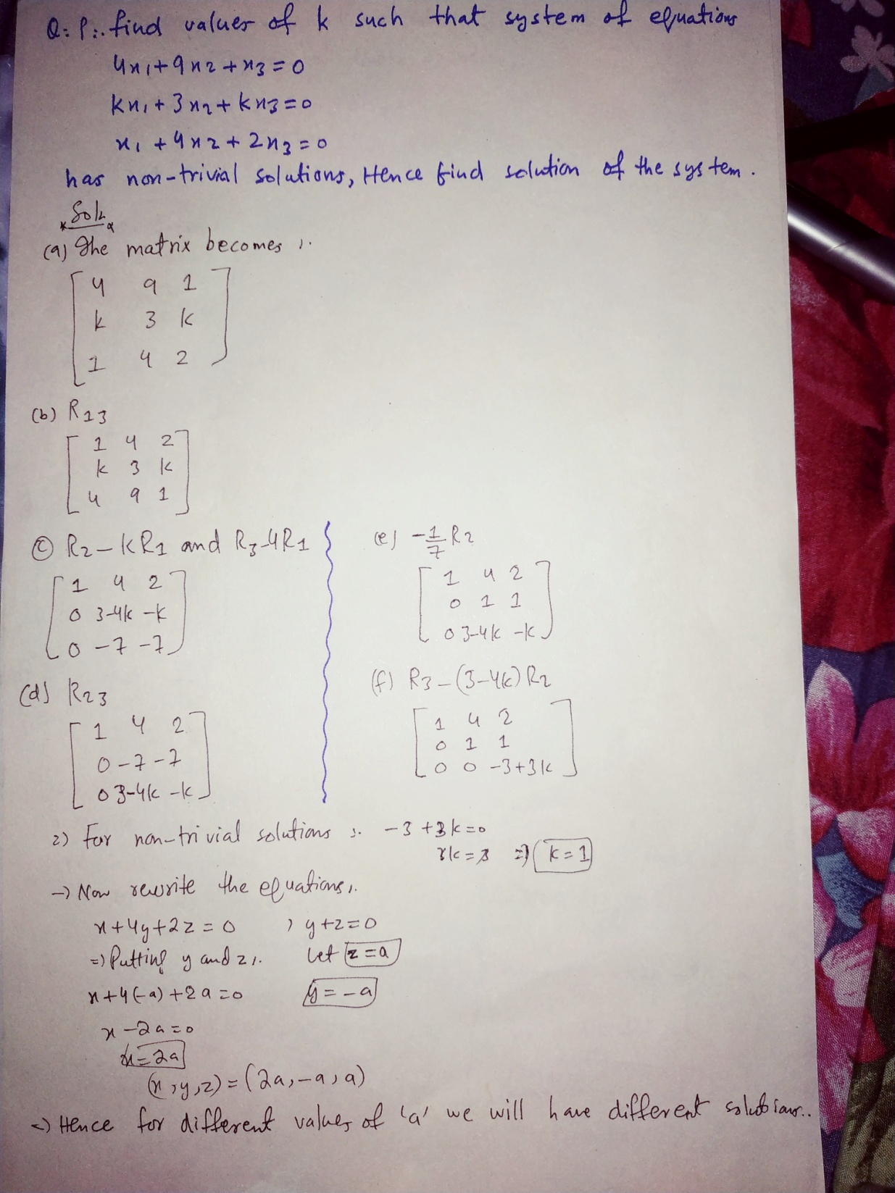

Q10. Determine the non – trivial solution (if any) of the following homogeneous system of linear equations:

$$\begin{matrix}x_{1} & - & 2x_{2} & + & 3x_{3} & - & 2x_{4} & = & 0 \\ 3x_{1} & - & 7x_{2} & - & 2x_{3} & + & 4x_{4} & = & 0 \\ 4x_{1} & + & 3x_{2} & + & 5x_{3} & + & 2x_{4} & = & 0\end{matrix}$$

**Solution:**

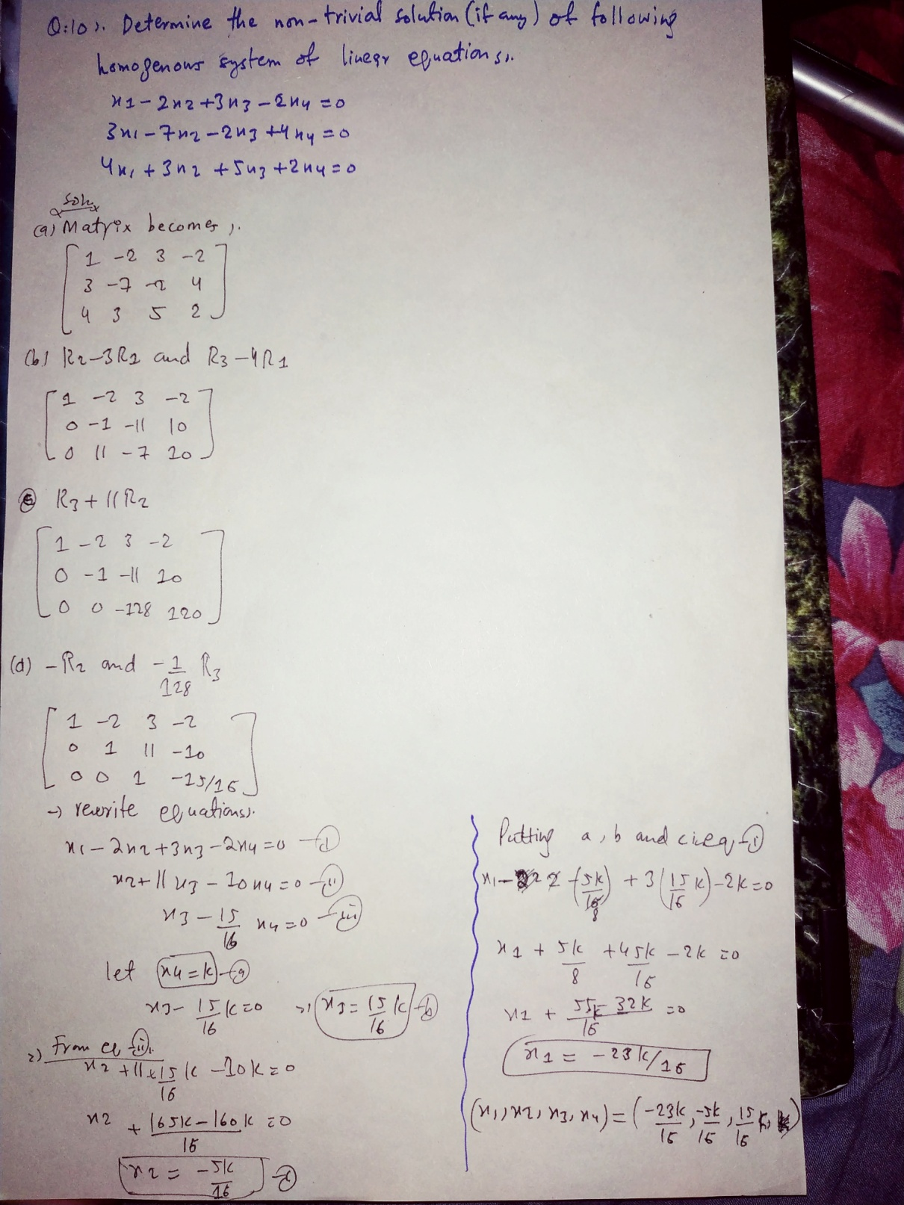

Q11. For the following network, (a) set up the system of equations that describes traffic flow; (b) determine the flows and  if  and (c) determine the maximum and minimum values for  if all the flows are constrained to be nonnegative.

800 400

400 *A**B*600

*x*4*x*2

400*CD*

200 *x*3 200 200

Q12. The flow of traffic (number of vehicles per hour) through a network of streets is shown in the following figure:

400 600



300 100

Q13. For the electrical networks *(i) – (ii)*, determine the currents in the various branches:

2*V*





*(i)*



4*V*

Solution:

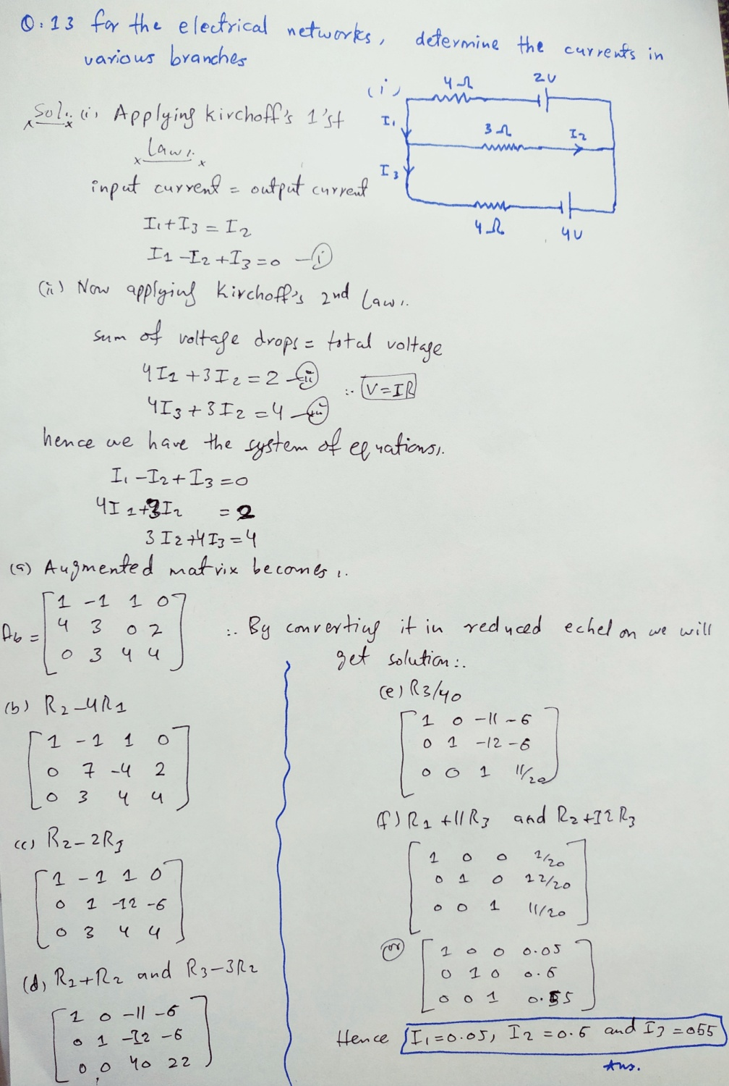

3*V*





*(ii)*





4*V*

***Solution:***

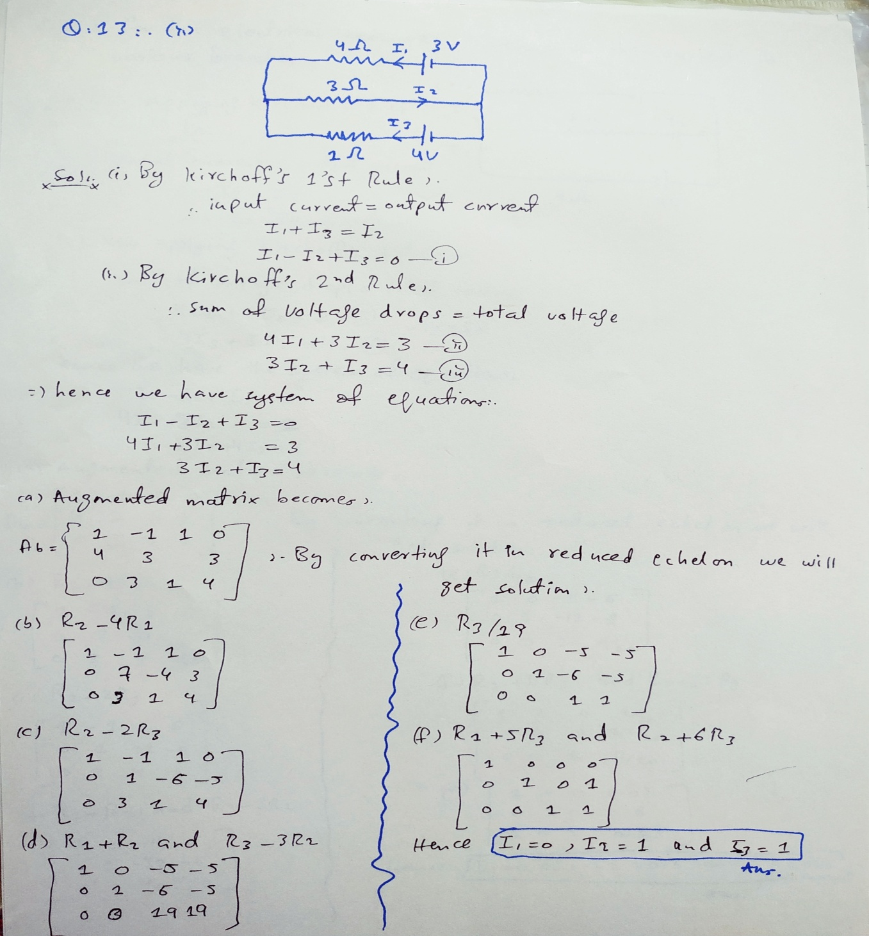

***THE END***